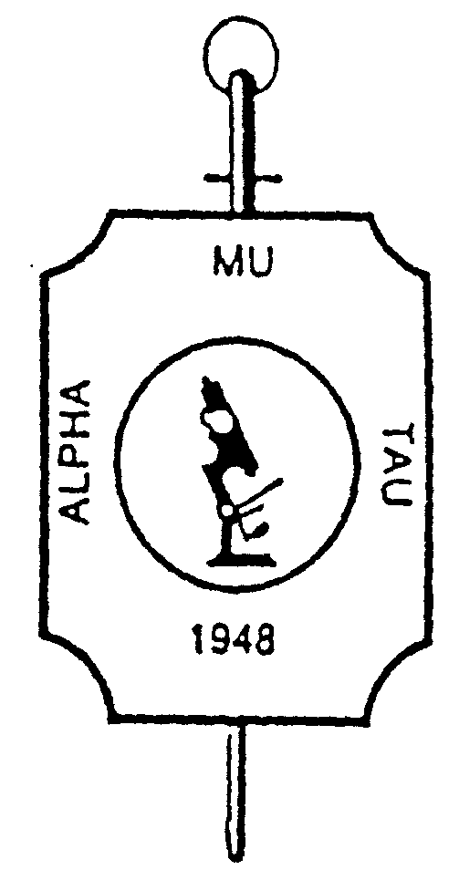 Alpha Mu Tau Fraternity

Expense Form

Committee or Office:_____________________________________________
Individual submitting request:______________________________________
Date submitted:_____________________
Request for Reimbursement (please itemize): Amount:
___________________________ $______________
___________________________ $______________
___________________________ $______________
___________________________ $______________

Total $______________
Please make check payable to:
Name:____________________________________
Address:__________________________________
__________________________________
Attach receipts and submit to:
Stephanie Jacobson
24665 Bender Ridge Road
Hermosa SD 57744
Stephanie.jacobson55369@gmail.com

Date Received: _____________________ Date Paid: _______________________ Check #_______________________

